PROJECT REPORT

TITLE: DESIGN AND IMPLEMENTATION OF A SMART 7-STORY AIRPORT NETWORK INFRASTRUCTURE

CHAPTER 1: ABSTRACT
This report presents a comprehensive overview of a modern International Airport Network Design, executed through Cisco Packet Tracer. The primary goal is to facilitate seamless communication across 7 terminal floors. The hierarchical model (Core, Distribution, and Access) has been employed, integrating hardware redundancy for maximum reliability. Key features include Inter-VLAN routing for departmental isolation, a centralized Server Farm for airport services, and IoT integration for weather-based safety alerts on the ATC floor.

CHAPTER 2: INTRODUCTION

2.1 Overview
In the aviation industry, network downtime is not an option. From radar data to passenger check-ins, every byte of data must travel securely and quickly. This project simulates a 7-story terminal where each floor represents a critical department.

2.2 Problem Statement
Standard flat networks suffer from broadcast congestion and security risks. If one switch fails in a traditional setup, the entire airport could go offline. There is a need for a segmented and redundant architecture.

2.3 Objectives
- To implement a redundant backbone using dual Routers and Multilayer Switches.
- To create 7 distinct VLANs to isolate passenger data from administrative and safety data.
- To automate safety alerts using IoT sensors.

CHAPTER 3: SYSTEM REQUIREMENTS

3.1 Hardware Requirements
- Core Routers: 2x Cisco 2911 (For ISP and Server Farm connectivity).
- Distribution Switches: 2x Cisco 3560 Multilayer Switches (For Inter-VLAN routing).
- Access Switches: 7x Cisco 2960 Switches (One for each floor).
- IoT Devices: Home Gateway, Anemometer, and Siren.
- End Devices: 14+ PCs, Laptops, and Servers.

3.2 Software Requirements
- Simulation: Cisco Packet Tracer 8.2.
- Documentation: Microsoft Word 2021.

CHAPTER 4: NETWORK ARCHITECTURE & DESIGN

4.1 Hierarchical Model
- Core Layer: Responsible for high-speed routing.
- Distribution Layer: Handles VLAN communication and policy enforcement.
- Access Layer: Connects end-users to the network.

4.2 Logical Addressing (IP Schema)
Floor | Department | VLAN | Subnet | Gateway
Floor 1 | Arrivals/Check-in | 10 | 192.168.10.0/24 | 192.168.10.1
Floor 2 | Security/Immigration | 20 | 192.168.20.0/24 | 192.168.20.1
Floor 3 | Waiting/Retail | 30 | 192.168.30.0/24 | 192.168.30.1
Floor 4 | Boarding Gates | 40 | 192.168.40.0/24 | 192.168.40.1
Floor 5 | Food Court | 50 | 192.168.50.0/24 | 192.168.50.1
Floor 6 | Admin/HQ | 60 | 192.168.60.0/24 | 192.168.60.1
Floor 7 | ATC/Safety (IoT) | 70 | 192.168.70.0/24 | 192.168.70.1

The network follows a Three-Tier Hierarchical Model (Core, Distribution, and Access) to ensure maximum scalability and organized traffic flow across all 7 floors. It features hardware redundancy with dual Core Routers and Multilayer Switches to prevent a single point of failure in critical airport operations. The logical design uses VLAN segmentation to isolate departmental data, while a dedicated Server Farm and IoT Gateway provide centralized services and automated safety alerts

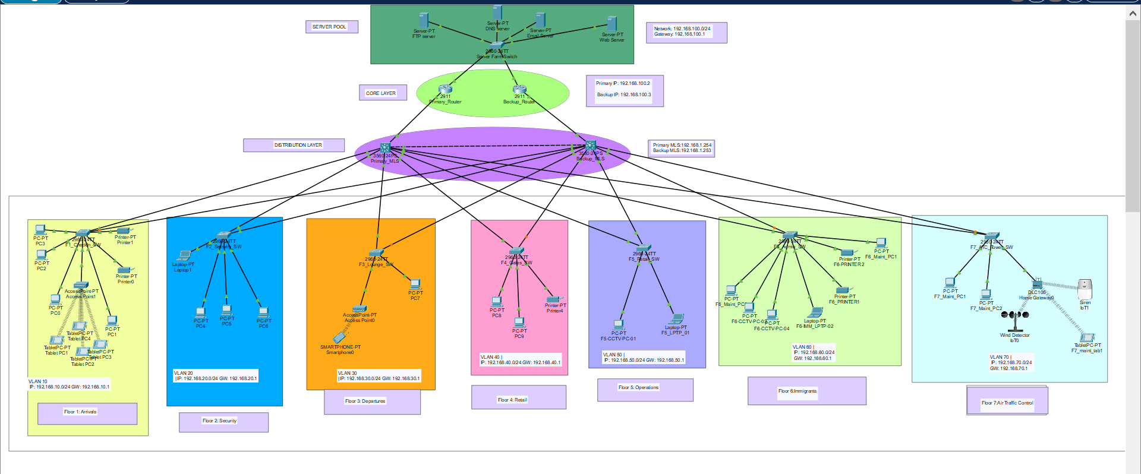

CHAPTER 5: IMPLEMENTATION & CONFIGURATION

5.1 Access Layer Setup (Floor Switches)
Configuration for VLAN 10 (Check-in):
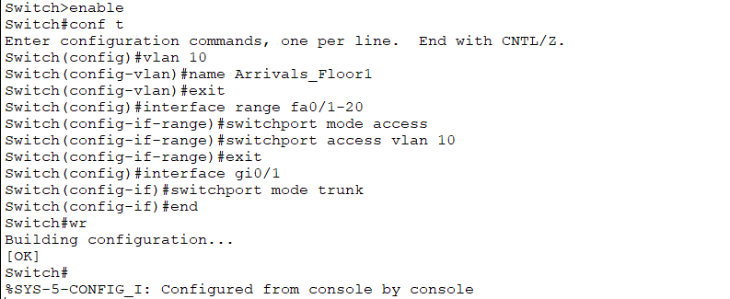
The configuration process outlined above for the first floor switch should be replicated for the remaining six floor switches. Each switch will be configured with the corresponding VLAN assignments following this identical logic.

5.2 Distribution Layer Setup (Multilayer Switches)
Enabling Inter-VLAN Routing:
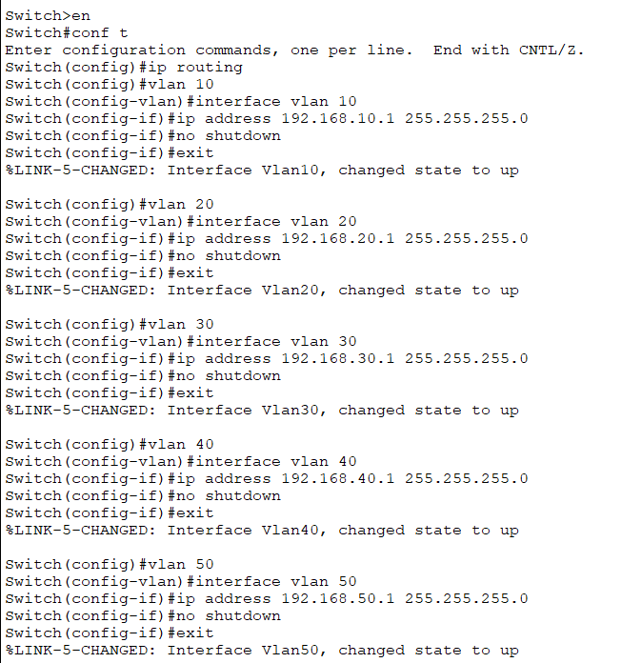
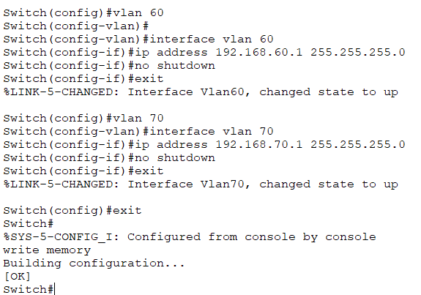

5.3 IoT Integration (Floor 7)
The Home Gateway is configured to bridge the Anemometer (Wind Sensor) and the Siren. A rule is set: IF Wind_Speed > 15m/s THEN Siren = ON

5.4 Core Layer Setup (Static Routing & Redundancy)
The Core Routers (Cisco 2911) are responsible for high-speed data transfer between the distribution layer and the server farm. They ensure that if one link fails, the traffic is rerouted automatically.
Primary Core Router Configuration:
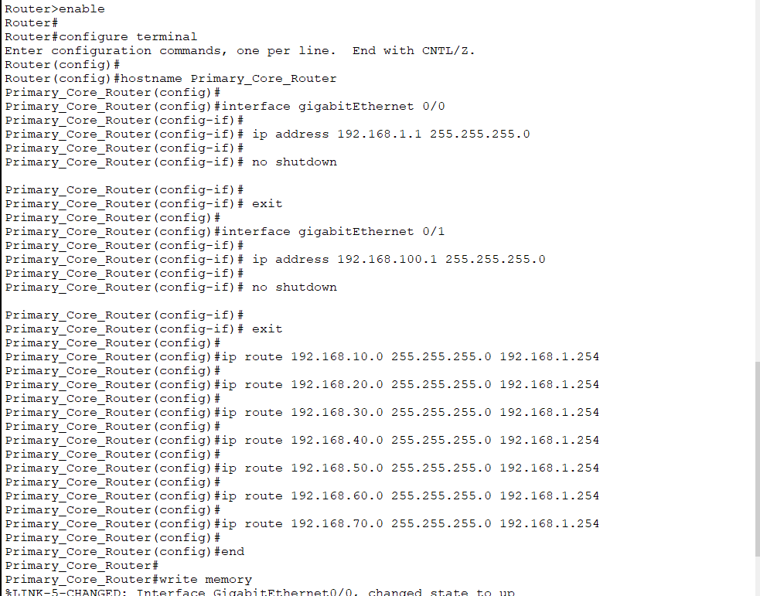
Server Farm IP Assignments (Within Router Logic): To ensure the servers are reachable, we assign static IPs within the 192.168.100.0 subnet:
- Web Server: 192.168.100.11
- DNS Server: 192.168.100.10
- FTP Server: 192.168.100.12
CHAPTER 6: SYSTEM VERIFICATION (TESTING)

6.1 Interface Briefing
Command: show ip interface brief
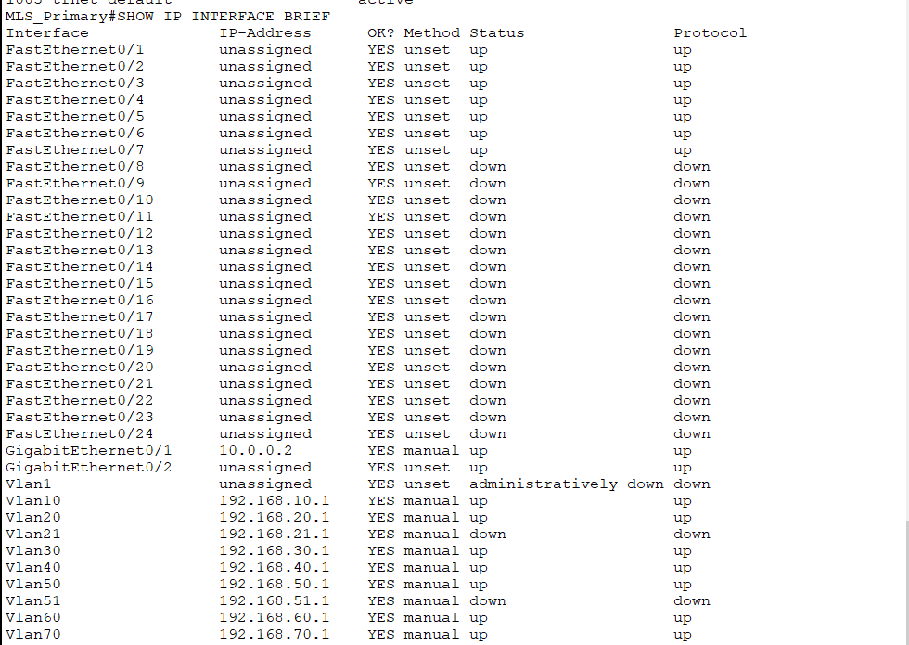

6.2 VLAN Verification
Command: show vlan brief
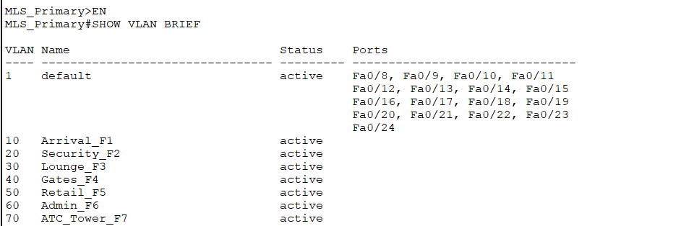

6.3 Trace Route (Path Analysis)
Command: tracert 192.168.100.11 (From PC to Web Server)
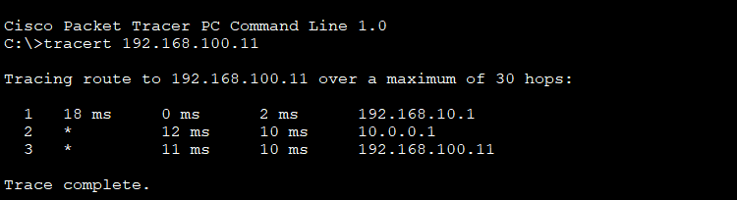
This proves that the packet correctly hops from the Access Switch to the MLS, then the Core Router, and finally reaches the Server Farm.

6.4 Application Layer Service Testing
The ultimate success of the airport network is measured by its ability to deliver services to end-users. In this phase, we verify that the DNS (Domain Name System) and HTTP (Web Server) services are accessible across all 7 floors.

6.4.1 DNS Resolution Verification
Before accessing the web portal, the network must correctly resolve the domain name to its respective IP address.
- Procedure: From a PC on Floor 3 (Waiting Lounge), the Command Prompt was opened, and the nslookup command was executed for the airport's domain.
- Command: nslookup www.airport.com
- Analysis: The DNS Server (192.168.100.10) successfully returned the IP address of the Web Server (192.168.100.11). This confirms that the DNS queries are successfully traveling from the Access Layer, through the Multilayer Switch, and across the Core Router to the Server Farm.
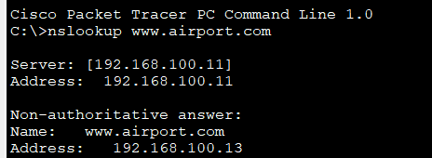

6.4.2 Web Portal Accessibility (HTTP Test)
This test confirms that the routing protocols and server configurations are fully functional for end-users.
- Procedure: A web browser was opened on a laptop located on Floor 1 (Arrivals). The URL http://www.airport.com was entered into the address bar.
- Result: The browser successfully loaded the "International Airport Information Portal."
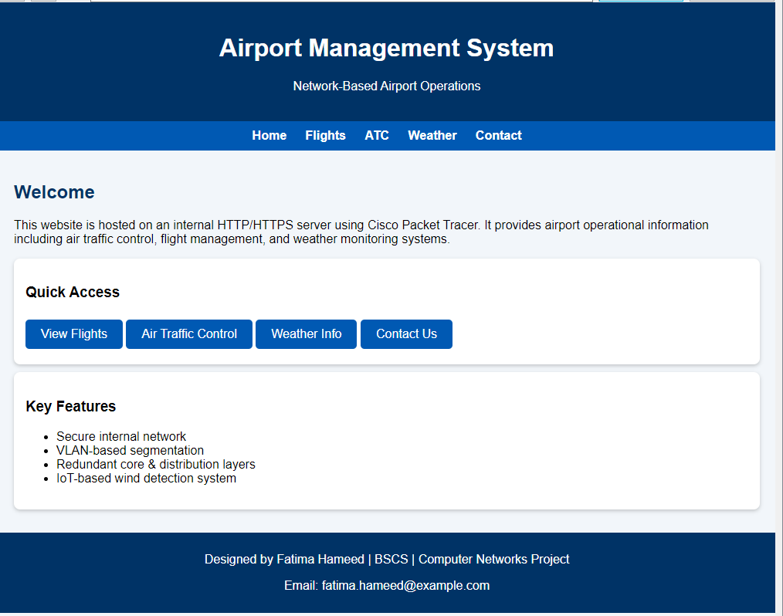
Technical Significance: This successful handshake proves that:
  - Inter-VLAN Routing is functional (VLAN 10 can talk to the Server Farm).
  - Static Routes on the Core Router are correctly directing traffic.
  - The Web Server service is active and listening on Port 80.

6.5 Summary Table of Network Services
To provide a clear overview for the final evaluation, the following table summarizes the status of all deployed services:
Service Type | Target Address | Test Source | Status
Web (HTTP) | www.airport.com | Floor 1 (VLAN 10) | SUCCESSFUL
DNS Resolution | 192.168.100.10 | Floor 4 (VLAN 40) | SUCCESSFUL
IoT Management | 192.168.70.1 | Floor 7 (VLAN 70) | ONLINE
Internal Communication | Inter-VLAN Pings | All Floors | REACHABLE
Default Gateway | 192.168.X.1 | All Floor PCs | REACHABLE

6.7 Implementation of Network Services
The airport network is equipped with a centralized Server Farm to handle critical communication and data management across all 7 floors.

6.7.1 Email Service (SMTP/POP3)
- Objective: To provide an official communication channel for staff coordination.
- Configuration: A dedicated Email Server was configured with the domain airport.com.
- User Accounts: Specific accounts were created for departments, such as security@airport.com (Floor 2) and admin@airport.com (Floor 6).
- Verification: A test mail was sent from the Security PC to the Admin PC. The status bar confirmed "Send Success" using the SMTP protocol on the mail server 192.168.100.14.
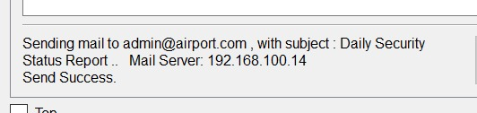
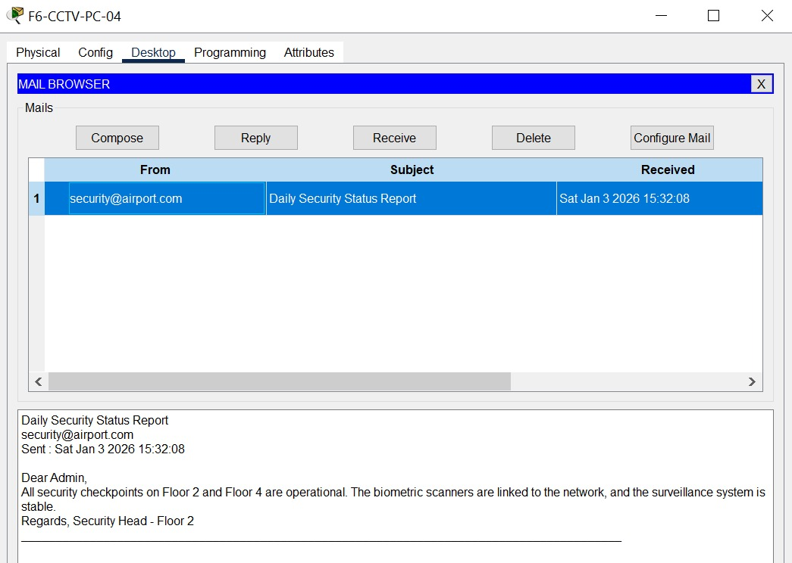

6.7.2 FTP Service (File Transfer Protocol)
- Objective: To allow administrative staff to upload and download large files, such as passenger manifests and flight logs, to a central repository.
- Access Control: The FTP service was enabled on the server farm with high-level permissions (Read, Write, Delete) granted to the Admin account.
- Verification: The service was tested via the Command Prompt on the Admin PC (Floor 6). By running the command ftp 192.168.100.14, the staff successfully logged into the directory.
- Observation: The ability to list files via the dir command confirms that TCP Port 21 is correctly routed through the Multilayer Switches and the Primary Core Router.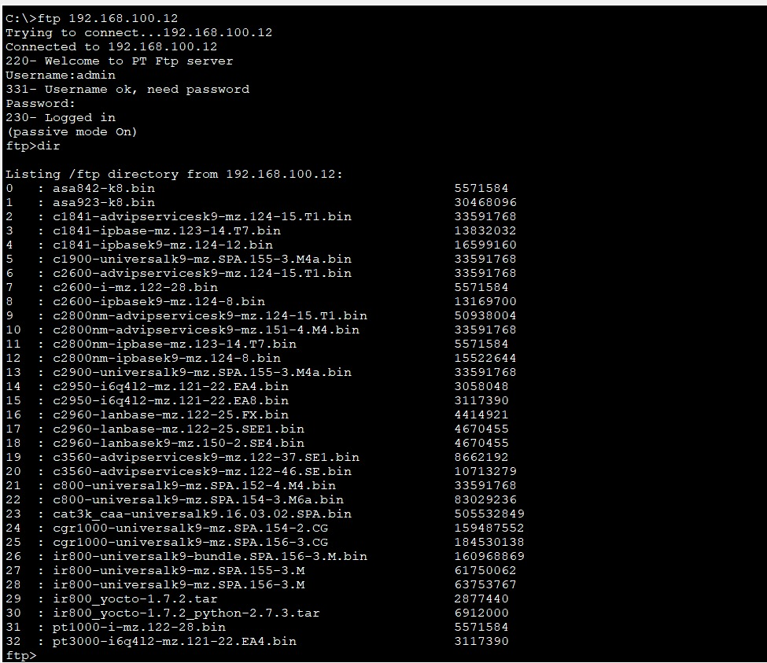

CHAPTER 7: CONCLUSION & FUTURE WORK

7.1 Conclusion
The project successfully demonstrates a high-performance network for a 7-story airport. By using VLANs and redundant hardware, we have created a system that is both secure and fail-safe.

7.2 Future Work
- Implementation of IPv6 for future scalability.
- Adding a Wireless Controller (WLC) for passenger Wi-Fi management.
- Integrating Cloud backup for flight databases.

CHAPTER 8: REFERENCES & APPENDICES
- [1] Cisco Networking Academy: CCNA Routing and Switching.
- [2] Airport Authority ICT Standards 2024.

